Lecture 2: Intelligent Agent

1. What is an Agent?
An agent is anything that can perceive its environment using sensors and act upon that environment through actuators. This concept covers a wide range of systems :
- Physical agents, such as robots that use cameras and motors to interact with the world.
- Software agents (Softbots), like programs that run tasks on computers or networks.

Un système qui comprend l’environnement en utilisant des capteurs, et peut agir dans cet environnement en utilisant des actionneurs.

Examples of intelligent systems:
- Robot
- MDS: Medical Diagnostic System
- IAS: Image Analys System (TESLA)
- TS: Tutoring System (Prof)

Agent Function vs. Agent Program :
- Agent function is a theoretical, mathematical concept that maps all possible percept sequences to actions.
- Agent program is the actual implementation of this function on a physical agent.

Components of an Agent:
- Architecture: The underlying hardware (physical or computational).
- Agent program: Software that decides how the agent responds based on percepts.

Example: Vacuum Cleaner World
This example shows how an agent in a vacuum cleaner environment can decide actions (like moving or cleaning) based on simple percepts (such as whether a location is dirty). However, the agent program can become complex as the number of percept sequences grows, leading to scalability issues.

2. Rationality and Rational Agents
A rational agent is one that selects actions to maximize its performance measure, which is a key principle in AI:
- Consequentialism: Actions are evaluated based on their outcomes.
- Utilitarianism: The goal is to maximize well-being or utility.

Characteristics of Rational Agents:
- Not omniscient: Rational agents can make mistakes when they lack sufficient information.
- Exploratory: Agents can learn and adapt by using percepts to improve their knowledge and become autonomous.
- Bounded by resources: Agents’ decisions can be constrained by factors like memory, computational power, and available sensors.

3. PEAS (Performance Measure, Environment, Actuators, Sensors)
The PEAS framework is a tool to describe an agent system, helping define its goals and structure.

Examples:
- Automated Taxi Driver:
  - Performance measure: Safe, legal, comfortable, fast, and profitable trip.
  - Environment: Roads, traffic, pedestrians.
  - Actuators: Steering, brakes, accelerator.
  - Sensors: Cameras, GPS, sonar.
- Spam Filter:
  - Performance measure: Accuracy (minimizing false positives and negatives).
  - Environment: Emails, servers.
  - Actuators: Marking emails as spam, deleting emails.
  - Sensors: Incoming messages, account data.

4. Types of Environments (contrôle)
Different environments pose various challenges for agents. The document categorizes environments based on several factors:
- Fully observable vs. Partially observable: Can the agent perceive the entire state of the environment, or only parts of it?
- Deterministic vs. Stochastic: Are the outcomes of actions predictable or random?
- Deterministic: Changes in the environment is completely determined by the current state of the environment and the agent’s action.
- Stochastic: changes cannot be determined from the current state and the action (there is some randomness).
- Strategic: the environment is stochastic and adversarial.it chooses actions strategically to harm the agent.
- Static vs. Dynamic: Does the environment change while the agent is deciding (deliberating) on actions?
- Semidynamic: the environment is static, but the agent’s performance score depends on how fast it acts.
- Known vs. unknown: does the agent knows the rules of the environment and can predict the outcome of actions or no?
- Discrete vs. Continuous: Are the possible states and actions finite or infinite?
- Episodic vs. Sequential: Does each action stand alone, or do actions influence future outcomes?
- Single-agent vs. Multi-agent: Is the agent operating alone, or in an environment with other agents that might compete or cooperate?

- Here's a table summarizing and comparing different types of environment properties for agents:
Environment Type | Option 1 | Option 2
Observability | Fully observable: The agent has access to the complete state of the environment. | Partially observable: The agent cannot access all aspects of the environment (e.g., can’t see through walls).
Determinism | Deterministic: Changes in the environment are fully determined by the current state and the agent’s action. | Stochastic: Environment changes have an element of randomness and are not fully determined by the current state and action.
Knowledge of Rules | Known: The agent understands the rules of the environment and can predict outcomes of actions. | Unknown: The agent cannot predict the outcomes due to lack of knowledge of the environment’s rules.
Strategic Environment | Non-strategic: Environment does not act adversarially against the agent. | Strategic: The environment is adversarial, making actions to harm the agent (e.g., in competitive games).
Dynamism | Static: Environment remains unchanged while the agent is deliberating. | Dynamic: Environment may change as the agent is deciding on actions.
Time Dependence | Semidynamic: Environment is static, but the agent’s performance is time-sensitive. | Fully dynamic: The environment changes continuously over time.
State/Action Space | Discrete: The environment has a finite, countable number of states, actions, and time steps. | Continuous: The environment has an infinite set of states, actions, or continuous time flow.
Task Structure | Episodic: Agent actions in one episode do not affect other episodes; tasks are self-contained. | Sequential: Agent’s actions in one task influence future tasks or episodes.
Agent Interaction | Single-agent: Only one agent interacts within the environment. | Multi-agent: Multiple agents cooperate or compete within the same environment.

Example Environments :
- Vacuum Cleaner World: Deterministic, partially observable, episodic, static, discrete, single agent.
- Taxi Driving: partially observable, stochastic, dynamic, sequential, continuous, multi-agent.

5. Hierarchy of Agent Types
Agents vary in complexity, from simple reflex systems to utility-based, learning agents.

1. Simple Reflex Agents:
- Use simple condition-action rules to determine behavior.
- No memory or understanding of long-term consequences.
- The agent does not know about the performance measure.
- The agent needs no memory and ignore all past percepts.
- Example: A basic vacuum cleaner that cleans when it detects dirt.

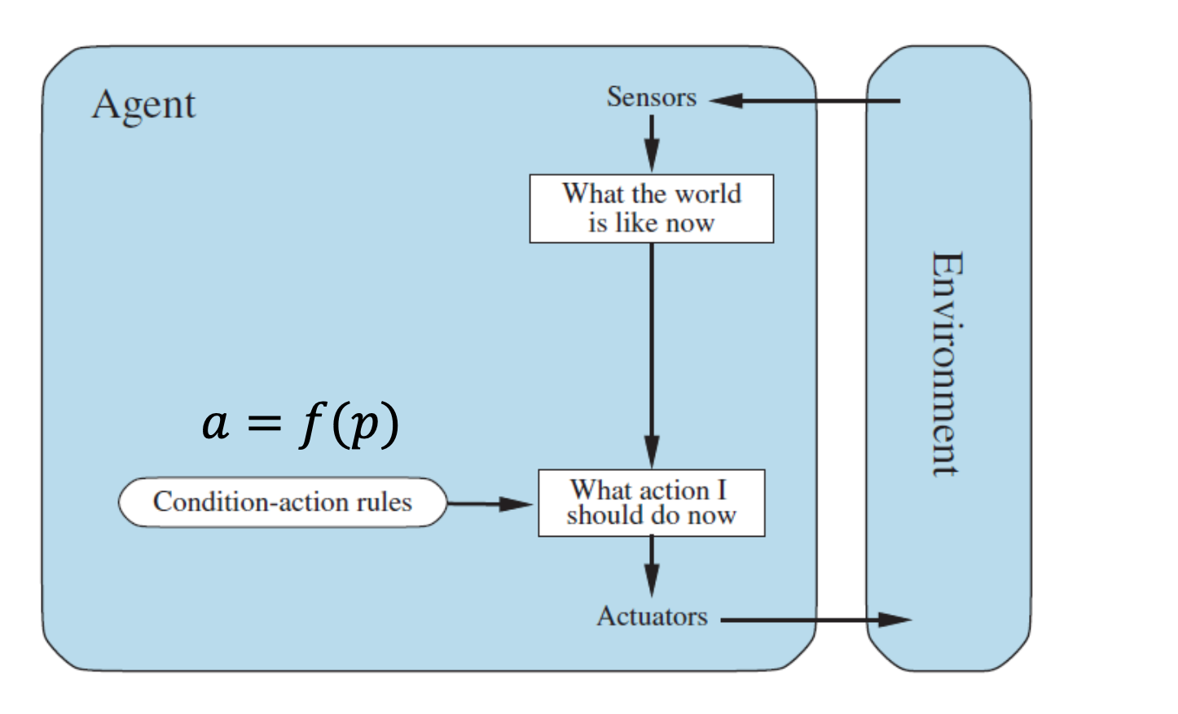

2. Model-based Reflex Agents:
- Track (il suit) the environment's state using memory, which helps in decision-making.
- Incorporate a transition function to predict how actions will change the state of the environment.
- The state is updated using the percept.
- Example: A vacuum cleaner that remembers which areas have already been cleaned.

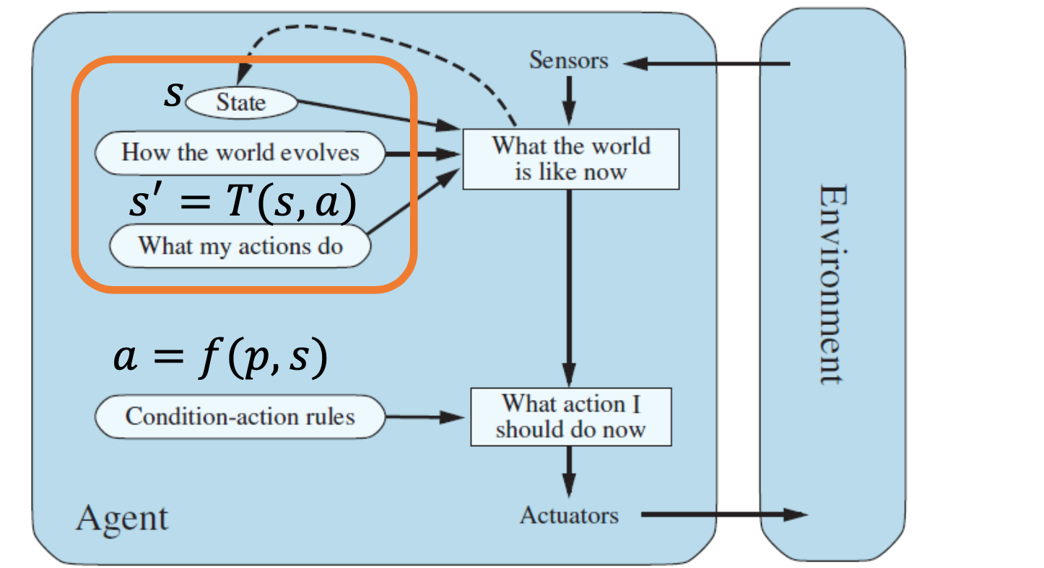

3. Goal-based Agents:
- Aim to achieve specific objectives.
- Use search algorithms to find the best sequence of actions to reach a goal.
- Performance measure: the cost to reach the goal.
- Example: A puzzle-solving agent that searches for the solution path.

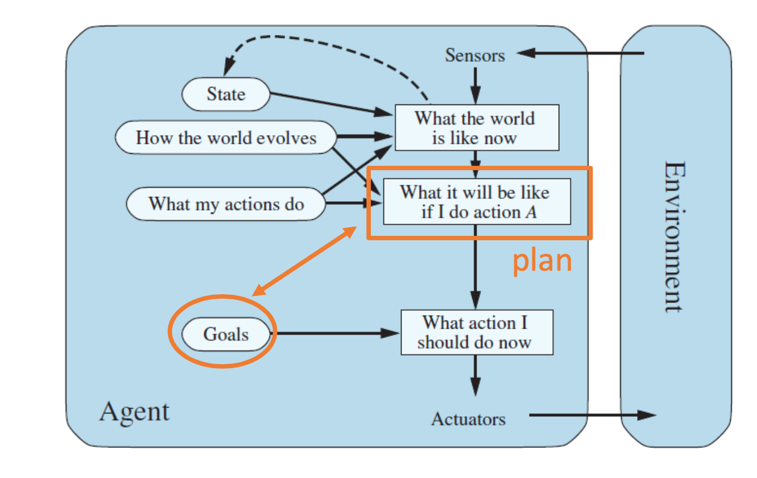

4. Utility-based Agents:
- Evaluate states based on a utility function, choosing actions that maximize long-term benefits.
- They are designed to stay in "desirable" states rather than just achieving short-term goals.
- Performance measure: the discounted sum of expected utility over time.
- Example: A Mars rover that balances battery life and exploration.
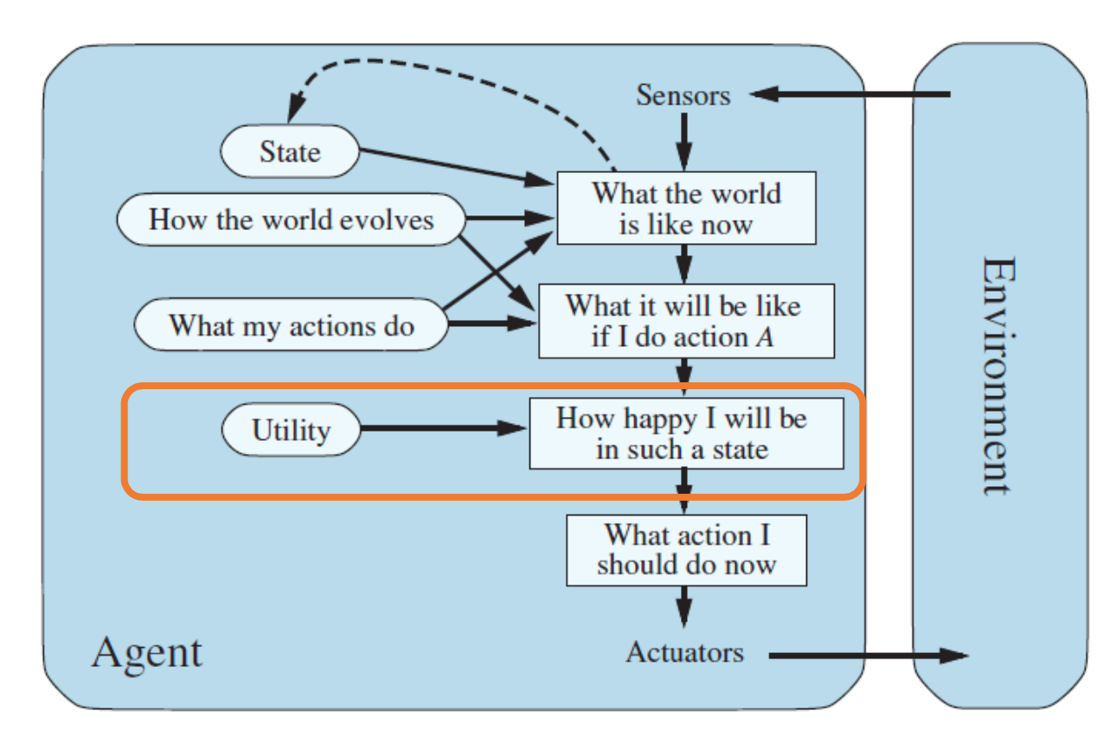

6. Learning Agents
Learning agents can adapt their behavior over time by updating their internal model based on experiences. They consist of :
- Learning element: Modifies the agent program.
- Performance element: Determines the agent’s behavior based on the learned knowledge.
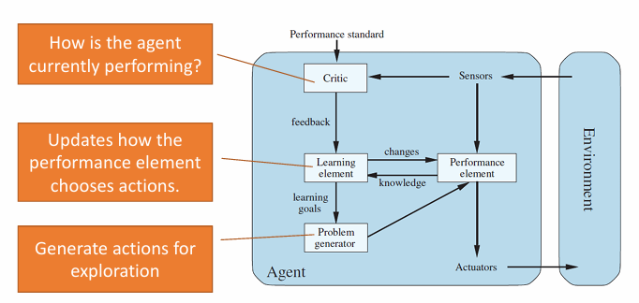

- Here's a table comparing different types of agents based on their complexity and functionality:
Agent Type | Description | Characteristics | Example
Simple Reflex Agents | Use simple condition-action rules to determine behavior. | - No memory  - Cannot consider long-term consequences. | Basic vacuum cleaner that cleans when it detects dirt.
Model-based Reflex Agents | Track the environment's state using memory for better decision-making. | - Maintain an internal state to remember past actions.  - Use a transition function to predict state changes. | Vacuum cleaner that remembers which areas have been cleaned.
Goal-based Agents | Aim to achieve specific objectives by finding the best sequence of actions. | - Use search algorithms to plan towards a goal.  - Actions are chosen to move closer to a defined goal. | Puzzle-solving agent that searches for the solution path.
Utility-based Agents | Choose actions based on a utility function to maximize long-term benefits. | - Aim to maintain “desirable” states.  - Weigh long-term utility over short-term goals. | Mars rover that balances battery life and exploration.

7. Real-World Examples
- Smart Thermostat: A model-based reflex agent with sensors that track temperature, occupancy, and other factors. It uses this information to optimize heating and cooling.
- Modern Vacuum Robot: Utility-based agent with advanced features like app control, mapping, and multiple cleaning modes.
- Self-Driving Cars: Combine multiple agent types (reactive, utility-based, and learning) to navigate complex, dynamic environments while ensuring safety and comfort.

8. Discussion on ChatGPT
The lecture touches on how large language models like ChatGPT fit into the framework of intelligent agents. They exhibit (exposition) characteristics of utility-based agents as they generate responses based on learned patterns. A key discussion question is whether ChatGPT can pass the Turing test, which evaluates a machine’s ability to exhibit intelligent behavior indistinguishable from that of a human.

9. Conclusion
The lecture concludes by outlining the main areas of AI research inspired by intelligent agents:
- Search algorithms: Agents looking for optimal solutions.
- Optimization: Agents trying to maximize utility while operating under constraints.
- Learning: Agents improving over time through experience.
- Uncertainty: Handling unpredictable environments and incomplete information.

Lecture: SEARCH STRATEGIES

What Are Search Problems?
Search problems are a central aspect of AI, where an agent needs to find a path from a starting point to a goal in an environment. The environment is assumed to be known, fully observable, and deterministic—meaning the agent has all necessary information and knows the outcome of every action it takes. This situation describes a goal-based agent, which focuses on reaching a specific goal state.

goal-based agent?
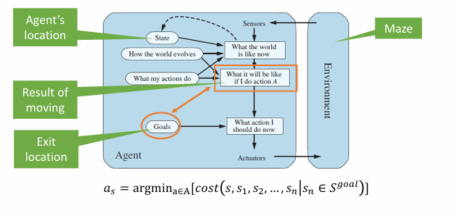

Components of Search Problems :
- Initial State: The starting condition or position of the agent (e.g., the starting city in a travel planning problem).
- Actions: The possible moves the agent can make (e.g., moving north, south, east, or west in a grid-based environment).
- Transition Model: Defines how the agent's actions affect the state. It describes what new state will result from applying a specific action in the current state.
- Goal State: The target or desired state that the agent needs to reach (e.g., the goal city in a travel planning problem).
- Path Cost: The cumulative cost of actions taken by the agent to move from the initial state to the goal state. In many cases, the goal is to minimize this cost.

Example Problem:
In the Romania Vacation Problem, the initial state is the agent being in Arad, and the goal state is reaching Bucharest. The actions are driving from one city to another, and the path cost is the total distance (measured in miles) the agent needs to travel.

2. State Space and Search Trees
The state space is the set of all possible states the agent could be in during the problem. For instance, in the Romania problem, each city is a state, and each road connecting cities represents an action that transitions the agent from one state to another.

Search Trees:
A search tree is used to represent the possible paths the agent can take from the initial state to the goal state. The root (racine) of the tree is the initial state, and the branches are actions leading to new states. Each node represents a state, and the edges between nodes represent actions.
However, search trees often encounter two main issues:
- Redundant Paths: Different action sequences may lead to the same state (e.g., taking different routes to the same city).
- Cycles: The agent may revisit the same state repeatedly, creating loops in the search process. To prevent this, cycles must be avoided to ensure the search is finite.

3. Types of Search Strategies
Search strategies are methods used by an agent to explore the state space and find the optimal path to the goal. Strategies are evaluated along the following dimensions:
- Completeness: does it always find a solution if one exists?
- Optimality: does it always find a least-cost (moins chère) solution?
- Time complexity: how long does it take?
- Space complexity: how much memory does it need?
These strategies can be divided into two main categories:
- Uninformed Search: The agent has no information about how close a state is to the goal. It blindly explores the search space.
- Informed Search: The agent uses a heuristic—a function that estimates how close a given state is to the goal—to guide its search.

4. Uninformed Search Algorithms
Uninformed search strategies explore the state space without specific information about which path will lead to the goal. Below are common uninformed search algorithms:
- Breadth-First Search (BFS);
- Depth-First Search (DFS);
- Uniform-Cost Search;
- Iterative deepening Search (IDS).

1. Breadth-First Search (BFS):
- How it works: BFS explores the shallowest (les moins profonds) nodes first. It uses a FIFO (First In, First Out) queue to store nodes for exploration. BFS systematically explores all nodes at depth before moving to depth.
- Properties:
  - Complete: Yes, BFS always finds a solution if one exists.
  - Optimal: Yes, BFS is optimal when all actions have the same cost. Otherwise: use Uniform-cost search.
  - Time Complexity: o(b^{d}) where b is the branching factor (the maximum number of successors from a state) and d is the depth of the shallowest (optimal) solution.
  - Space Complexity: o(b^{d}) meaning BFS uses a large amount of memory because it stores all nodes at each level of the tree.
- d: depth of the optimal solution
- m: max.depth of tree
- b: maximum branching factor
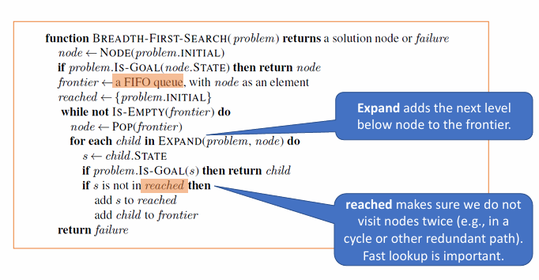
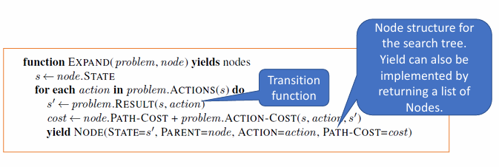

2. Depth-First Search (DFS):
- How it works: DFS explores the deepest nodes first. It uses a LIFO (Last In, First Out) stack for its frontier, diving deep into the tree before backtracking.
- Properties:
  - Complete: Only for finite search spaces. DFS can get stuck in infinite loops if it revisits the same state.
  - Optimal: No, DFS may return suboptimal solutions since it doesn't always explore the shallowest path first.
  - Time Complexity: O(b^{m}), where m is the maximum depth of the tree. In the worst case, DFS explores the entire depth of the search tree.
  - Space Complexity: O(bm), which is more memory-efficient than BFS since it only needs to store the current path from the root to the deepest explored node.
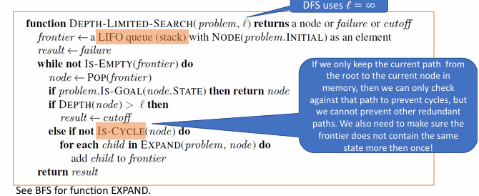

3. Uniform-Cost Search:
- How it works: This algorithm expands the node with the least path cost from the initial state. It is essentially a generalization of BFS where each step may have a different cost. The algorithm uses a priority queue to always expand the cheapest node.
- Properties:
  - Complete: Yes, as long as the step costs are greater than zero.
  - Optimal: Yes, uniform-cost search always finds the least-cost solution.
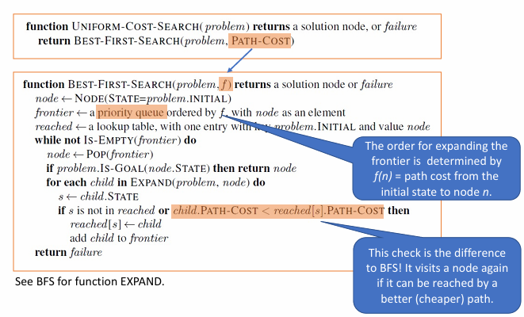

4. Iterative Deepening Search (IDS):
- How it works: IDS is a combination of DFS and BFS. It performs DFS up to a limited depth and iteratively increases this limit, restarting the search each time.
- Properties:
  - Complete: Yes, IDS is guaranteed to find a solution.
  - Optimal: Yes, when step costs are uniform.
  - Time Complexity: slower than BFS, but the same complexity class.
  - Space Complexity: O(bd), much lower than BFS because it only stores the current path and the nodes in the current depth-limited iteration.
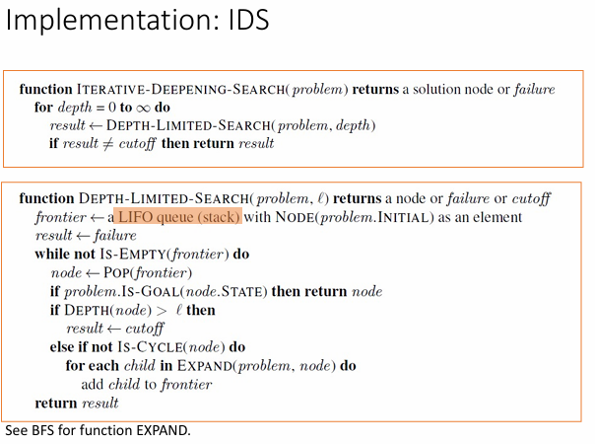

5. Informed Search Algorithms
Informed search strategies improve efficiency by using heuristics—functions that estimate the cost from the current state to the goal. This extra information helps the agent prioritize exploring states that seem more promising.

1. Greedy Best-First Search:
- How it works: Greedy best-first search expands the node that appears closest to the goal based on the heuristic function h(n), which estimates the cost from node n to the goal.
- Properties:
  - Complete: Yes, in finite search spaces.
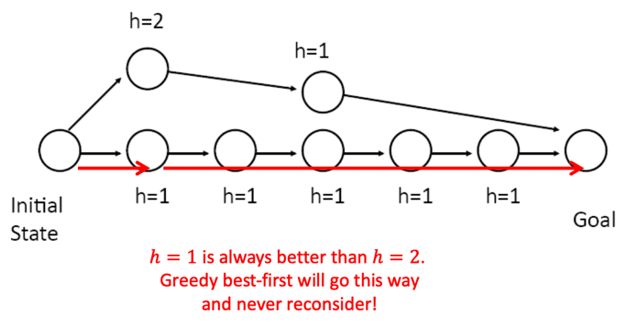
  - Optimal: No, greedy search does not guarantee an optimal solution as it may take the "shortest" path according to the heuristic, which might not be the least-cost path.

Greedy best-first search =Best-First Search + Expand the frontier using 𝑓 (𝑛) =ℎ(𝑛)

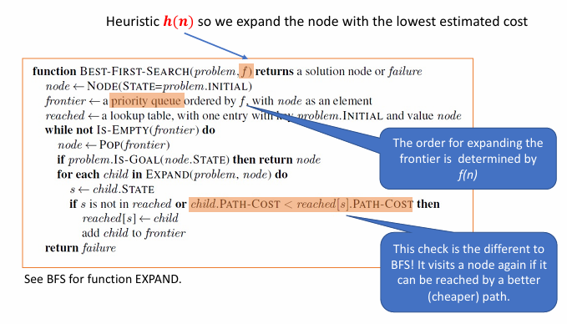

2. A* Search:
- How it works: A* search balances the cost of the path so far (g(n)) with the estimated cost to the goal (h(n)). It expands the node with the smallest evaluation function f(n)=g(n)+h(n).
- Properties:
  - Complete: Yes, A* always finds a solution if one exists.
  - Optimal: Yes, if the heuristic is admissible (it never overestimates the actual cost to reach the goal).
  - Time and Space Complexity: Both are exponential in the worst case. The efficiency of A* depends on the quality of the heuristic.
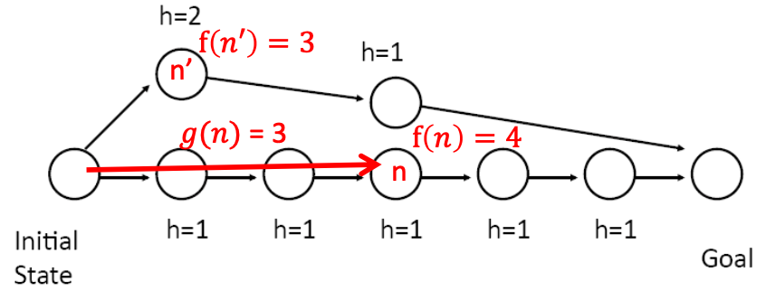

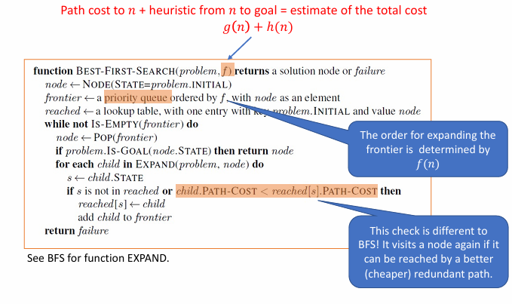

Optimality: Admissible Heuristics
Definition: A heuristic ℎ is admissible if for every node 𝑛, ℎ 𝑛 ≤ ℎ∗(𝑛), where ℎ∗(𝑛) is the true cost to reach the goal state from 𝑛.
I.e., an admissible heuristic is a lower bound and never overestimates the true cost to reach the goal.
Example: straight line distance never overestimates the actual road distance.
Theorem: If ℎ is admissible, A* is optimal.

6. Properties of Search Strategies
Each search algorithm has its own trade-offs in terms of completeness, optimality, time complexity, and space complexity. The choice of strategy depends on the problem's requirements and constraints:
- BFS is memory-intensive but guarantees finding the shallowest solution.
- DFS is memory-efficient but can miss optimal solutions.
- IDS combines the benefits of DFS and BFS but may have higher time costs due to repeated searches.

Summary of Properties of Search Strategies
Algorithm | Completeness | Optimality | Time Complexity | Space Complexity | Strengths | Weaknesses
BFS | Yes | If all step costs are equal | O(b^{d}) | O(b^{d}) | Guaranteed to find the shallowest solution | High memory usage, impractical for large trees
DFS | No (infinite) | No | O(b^{m}) | O(bm)) | Space-efficient for deep problems | Can miss optimal solutions, infinite loops possible
IDS | Yes | If all step costs are equal | O(b^{d}) | O(bd) | Combines efficiency of DFS with completeness of BFS | Higher time costs due to repeated searches
Greedy best-first Search | In finite spaces (cycles checking) | No | Depends on heuristic | Worst case : O(b^{m})  Best case: O(bd)
A* | Yes | Yes (admissible heuristic) | Number of nodes with  g(n) +h(n)<=C* |  | Optimal solutions with good heuristics | High memory requirements for large search spaces

Search with Uncertainty

1. AND-OR Recursive DFS Algorithm (Nondeterministic Environments)
This algorithm handles environments where each action has uncertain outcomes, making it ideal for problems requiring conditional plans (strategies that depend on different scenarios).

Key Concepts of AND-OR Recursive DFS
Concept | Description
AND-OR Tree | A tree where OR nodes represent decision points (action choices), and AND nodes represent action outcomes that must all be accounted for in a plan.
Belief State | Represents the set of possible states the agent could be in, allowing it to plan for multiple scenarios without knowing its exact current state.
Conditional Plan | A sequence of actions that adjusts based on observed outcomes; the solution is a plan subtree where all paths lead to the goal.
Cycle Avoidance | Tracks visited nodes to prevent infinite loops in cyclic environments.
Recursive Approach | Recursively explores each choice (OR nodes) and their possible outcomes (AND nodes), building a conditional plan that ensures the agent reaches a goal state.

Detailed Pseudocode for AND-OR Recursive DFS
python
Copy code
def AND_OR_SEARCH(problem):
# Starts the search with the initial state and an empty path to prevent cycles
return OR_SEARCH(problem.initial_state, problem, [])

def OR_SEARCH(state, problem, path):
if problem.is_goal(state): # Goal test
return [] # Returns an empty list as the solution if a goal state is reached

if state in path: # Prevents cycles by checking if the state has been visited
return None

for action in problem.actions(state): # Explore each action at the OR node
plan = [] # Initializes a potential solution for this action

# AND node: considers all resulting states from the action
for s_prime in problem.results(state, action):
result = AND_SEARCH(s_prime, problem, path + [state])
if result is None: # Abandon action if any branch fails
break
plan.append(result)

if plan: # Return plan if all branches succeed for the action
return [action] + plan

return None # Return None if no action leads to goal states

def AND_SEARCH(states, problem, path):
# Checks if every outcome of an action leads to a goal by applying OR_SEARCH on each result
for s in states:
plan = OR_SEARCH(s, problem, path)
if plan is None: # If any branch fails, abandon the entire AND node
return None
return []

Summary of Algorithm Components
Component | Role in Algorithm | Explanation
AND-OR Tree | Structure for conditional plans | OR nodes represent choices; AND nodes cover all outcomes for each action.
OR_SEARCH | Examines each action to create a conditional plan | For each action, AND_SEARCH is used to verify that all possible outcomes (AND nodes) can reach a goal.
AND_SEARCH | Ensures that all outcomes of an action lead to a goal | Calls OR_SEARCH recursively for each state to confirm goal attainment under all conditions.
Cycle Prevention | Avoids repeated states to prevent infinite loops in recursive DFS | Checks if a state has been visited before, breaking the cycle if so.

Practical Considerations for AND-OR Recursive DFS
Advantage | Challenge | Use Case
Guarantees a solution if a conditional plan exists. | Depth-first recursion can revisit nodes, which is inefficient. | Ideal for games, robot planning, or AI requiring robust contingency plans in uncertain environments.

2. Online DFS with Backtracking (Unknown Environments)
This algorithm is designed for exploration in unknown environments where the agent learns the state transitions while acting. It uses backtracking to revisit states when necessary and builds a model of the environment as it moves.

Key Concepts of Online DFS with Backtracking
Concept | Description
Exploration & Observation | The agent tests each action to learn outcomes, building a transition model as it explores.
Backtracking | The agent returns to prior states when all actions in a state are exhausted, using “breadcrumbs” to avoid getting lost.
Transition Recording | Records each state-action result to avoid redundant exploration, gradually forming a map of the environment.
Safety Consideration | Suitable for environments where exploration is safe and actions are reversible; backtracking assumes the agent can revisit states.

Detailed Pseudocode for Online DFS with Backtracking
python
Copy code
def ONLINE_DFS_AGENT(state, problem):
if problem.is_goal(state): # Check for goal state
return [] # Returns empty action list when the goal is reached

# Initialize state tracking if it's a new state
if state not in problem.untried:
problem.untried[state] = problem.actions(state)
if state not in problem.unbacktracked:
problem.unbacktracked[state] = []

# Try an untried action
if problem.untried[state]:
action = problem.untried[state].pop() # Select an untried action
problem.unbacktracked[state].append(action) # Save for backtracking
result = problem.act_and_observe(state, action) # Perform action and observe result
problem.result[state, action] = result # Record the result for future reference
return action

# Backtrack if no untried actions remain
elif problem.unbacktracked[state]:
action = problem.unbacktracked[state].pop() # Retrieve backtracking action
return action

# Return None if no actions remain and the goal hasn't been found
return None

Summary of Algorithm Components

Component | Role in Algorithm | Explanation
Goal Check | Verifies if the current state is the goal | Stops the search if the goal is reached.
State Initialization | Sets up tracking of actions for each new state | Tracks untried and backtracked actions to avoid redundant exploration.
Action Execution | Executes untried actions to observe outcomes | Records the result to build a model of the environment incrementally.
Backtracking | Returns to previous states when all actions are exhausted | Allows continued exploration of unvisited paths by revisiting prior states.

Practical Considerations for Online DFS with Backtracking
Advantage | Challenge | Use Case
Builds knowledge of the environment while acting, which is useful when the environment is unknown. | Assumes actions are reversible and the environment is safe for exploration. | Best for navigating unknown terrains or mazes where layout is initially unknown.

Comparison of AND-OR Recursive DFS vs. Online DFS with Backtracking
Feature | AND-OR Recursive DFS | Online DFS with Backtracking
Primary Use Case | Planning in uncertain environments where actions have multiple outcomes. | Exploration in unknown environments without prior knowledge of transitions.
Solution Type | Conditional plan covering all contingencies. | Incremental exploration with model building.
State Tracking | Uses belief states to manage uncertainty across different outcomes. | Tracks visited states and untried/backtracked actions for efficient exploration.
Cycle Handling | Prevents cycles by recording visited states in path. | Uses backtracking to return to unexplored paths without revisiting cycles.
Optimization | Not optimal, as it may revisit nodes due to depth-first structure. | Becomes more efficient over time by building a transition model.
Ideal Application | Game AI, robot navigation with uncertain actions. | Autonomous exploration, maze solving, navigating unknown environments.

Summary Table for Practical Applications
Algorithm | Ideal Application | Example
AND-OR Recursive DFS | Decision-making with uncertain actions | Game strategy trees, robotics planning in environments with unknown outcomes.
Online DFS with Backtracking | Exploring unknown environments without pre-built models | Maze solving, autonomous robot navigation, mapping unknown terrains.

